ServicePoint (HMIS) Committee Minutes
Date: Tuesday, September 25, 2018 Time: 2:30 pm
Place: Central Permit Facility
500 W Winchester Rd. Libertyville, IL

1.0 |  | Call to Order & Introductions  Call to Order: 2:38 PM  Present: David Fries, Greg Mavromatis, Dan Kletzing, Yareli Salgado
2.0 |  | Approval of Minutes
2.1 |  | August 28
3.0 |  | Chair’s Remarks
4.0 |  | Staff Reports
4.1  4.2  4.3  4.4 |  | HMIS Reports  - LSA is the new AHAR (behind schedule)  HUD left out a piece of the specs needed for the vendors to develop this report. The vendors have been granted an extension. HUD is working closely with vendors and data collection staff to finalize the reporting timeline for LSA data submission. We will be given an official submission deadline as well as interim milestones to stay on track.  - APR update 10/1 – better layout of housing move-in date  This report will better capture the data standards that were changed last year. Those changes mainly impacted PSH providers (RRH was already collecting the information).  No New Data Standards  No changes to the current data collection process for all HMIS agencies. HUD has already stated that there will be changes next year.  WellSky Community Services  - Branding Timeline  Mediware has been acquired by WellSky. ServicePoint 5 will not be rebranded, but ServicePoint 6 will be called “WellSky Community Services”.  - ServicePoint 6/Wellsky Community Services Timeline Update  WellSky is projecting an initial launch with limited modules in the first half on 2019. Lake County would have to wait for the second launch which is predicted to be Mid-2019.  SSVF Implementation  Pending meeting with Millicent. Yareli will get meeting dates and send them to Dave so he can schedule a meeting.
5.0  5.1  6.0  6.1  6.2 |  | Old Business  HMIS Coverage Action Plan  Discussed progress made with VA and Data Services agreements. We are a couple steps closer to having VASH on HMIS.  New Business  Data sharing policy - Individual Agency Data  HMIS Admin was seeking clarification. The committee recommended asking Kate (who helped write the policies) for clarification. This topic will be revisited with Kate’s clarification.  Point in Time Count  The Point in Time Count was previously organized by a work group under System Coordination and Entry Committee. Brenda and the chair spoke about moving that work group to HMIS Committee since this event helps us submit data to HUD. The work group will meet in October and bring a methodology for this committee to approve and send to the full board.
7.0 |  | Adjournment

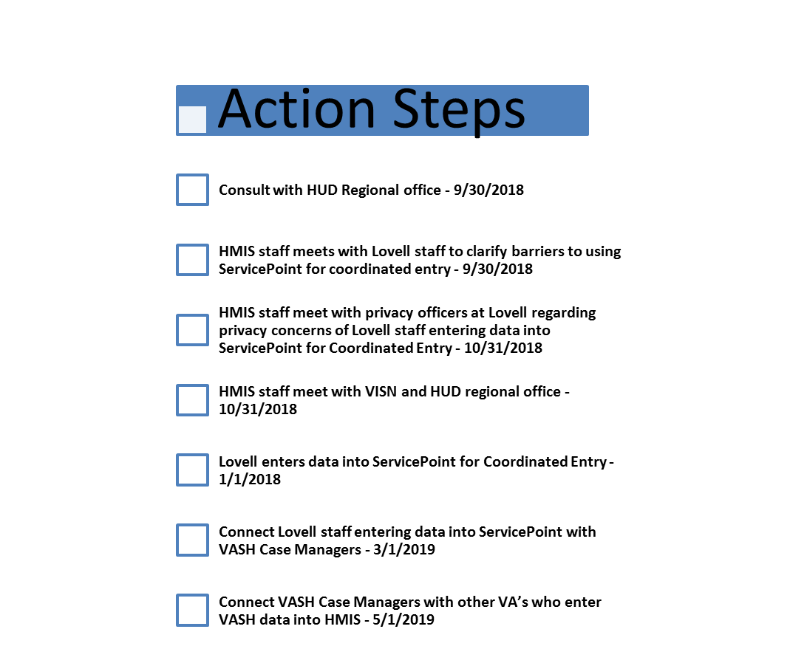

Coming Soon?

