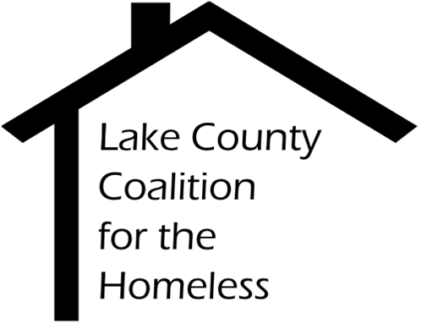

ServicePoint (HMIS) Committee Minutes
Date: Tuesday, July 24, 2018 Time: 2:30 pm
Place: Central Permit Facility
500 W Winchester Rd. Libertyville, IL

1.0 |  | Call to Order & Introductions  Call to Order: 2:34 PM  Present: David Fries, Greg Mavromatis, Joel Williams, Yareli Salgado
2.0 |  | Approval of Minutes
2.1 |  | June 19 minutes approved with one correction
3.0 |  | Chair’s Remarks  None.
4.0 |  | Staff Reports
4.1  4.2  4.3 |  | HMIS Reports  - LSA is the new AHAR  - Currently being developed by Mediware.  To be released in October and will be due in December.  Data Quality Framework Q2  Reviewed common errors, discussed strategies and different ways to break data down.  SSVF Implementation  Pending meeting with Catholic Charities
5.0  5.1  6.0  6.1  6.2 |  | Old Business  HMIS Coverage – PADS Housing First on HMIS  Agreed to be on HMIS as Permanent Supportive Housing.  New Business  Data Sharing Policies  Recommended a change to the Security Protocol section of the HMIS policies. Aggregate data can be shared with Non-Partner Agencies freely. HMIS Leads will notify HMIS committee and board of data requests.  HMIS Coverage Action Plan  Committee agreed to the idea of an HMIS Coverage Action Plan. Details will be discussed at the next meeting.
7.0 |  | Adjournment

