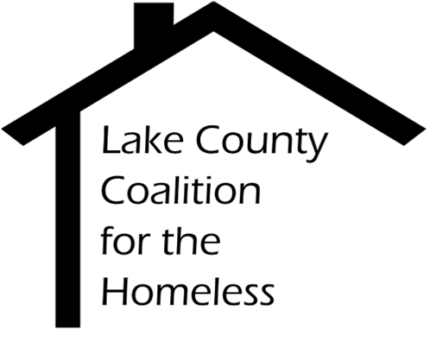

ServicePoint (HMIS) Committee Minutes
Date: Tuesday, June 19, 2018 Time: 10:00 am
Place: Lake County Health Department
3010 Grand Avenue Waukegan, IL

1.0 |  | Call to Order & Introductions
2.0 |  | Approval of Minutes
2.1 |  | May 30 - Approved
3.0 |  | Chair’s Remarks
4.0 |  | Staff Reports
4.1  4.2 |  | Data Quality Framework Q1  HMIS Committee will continue to review these frameworks and look for trends.  SSVF Implementation  Pending meeting with Catholic Charities Chicago office
5.0  5.1  6.0  6.1 |  | Old Business  HMIS Coverage – PADS Housing First on HMIS  HMIS Administrator will be meeting with PADS to decide whether Housing First will be PSH or OPH  New Business  ServicePoint Coordinating Council Update  Committee chair gave an update of the items reviewed during the ServicePoint Coordinating Council. Next meeting 7/9/2018 at 1:30 PM
7.0 |  | Adjournment  Next Meeting: July 24th @ 2:30 PM in Libertyville

