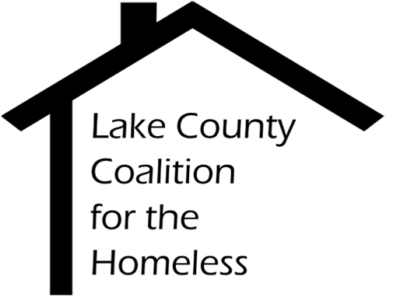

ServicePoint (HMIS) Committee Minutes
Date: Tuesday, November 28, 2017 Time: 2:30 pm
Place: Lake Health Department
3010 Grand Ave Room 1C, Waukegan, IL 60085

1.0 |  | Call to Order & Introductions
2.0 |  | Approval of Minutes
3.0 |  | Chair’s Remarks
4.0 |  | Staff Reports
4.1  4.2  4.3  4.4 |  | HMIS Reports  - AHAR final data is due 12/1, ½ is submitted, vets are left  - System Performance measures initial actions have been made by the due date, Yareli and Brenda now have time to clean up the data (no due date)  - Yareli did Agency Administration training last week  - Point in Time Reporting is coming soon.  Referral Network Implementation  - Community Development is funded for year 2 of the Referral Network  - PCP referrals are live  - The technology is set for Workforce Development referrals  Uses of ServicePoint Presentation  - Brenda gave a presentation reviewing all uses of ServicePoint  Privacy Framework  - There are drafts of client consent and agency agreement forms that cover all ServicePoint users.  - This will be presented at the next committee meeting.
5.0  5.1  5.2  6.0  6.1  6.2 |  | Old Business  Data Quality Framework  - Re-reviewed at agency admin meeting  - 3 agencies have still not submitted  - Yareli will stay in contact with admin about quality  - Committee discussed rationale for a timeliness exception for emergency shelter  - Next report will be in January  SSVF Data  - Brenda has reached out to TLS Veterans, there is no set meeting yet  New Business  Charter Review  - Committee approved the charter with minimal changes  Building Committee  - Reach out to people that would make good committee members!
7.0 |  | Adjournment  NEXT MEETING: January 23rd, Central Permit Facility

