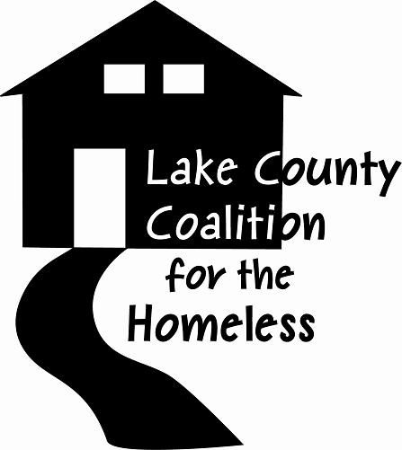
Community Engagement, Advocacy & Membership Committee Agenda
Date: June 4th, 2019 Time: 9:30 a.m
Place: United Way of Lake County,
330 S. Greenleaf, Gurnee, IL 60031
Agenda
1.0 |  | Call to Order & Introductions
2.0 |  | Approval of Minutes
2.1 |  | May 7th, 2019 Minutes
3.0 |  | Chair’s Remarks
4.0 |  | Old Business- Rescheduling Sandy Hart, Lake County Board President or an attendee to provide an overview of plans for Crisis center.
4.1 |  | New Business –  - August Community Event  - New Memberships and renewals  - Follow up meeting with Mayor July 16th  - Review Powerpoint and updates
5.0 |  | New presentation Opportunities  LCCH programs for meetings in July (Needs Assessment) and recap of meeting with the Mayor  August Community Event  September- Suicide Prevention Month (presenter Sandy Hart or NAMI)  October- Domestic Violence Awareness Month  Advocacy – What else should we be doing relative to advocacy?  Other
6.0 |  | Member Comments
7.0 |  | Adjournment

